

Financial Management System with Machine Learning Support

Chapter 2

Caleigh Susan Anak Jeffry

Bachelor of Software Engineering with Honours
2025
Table of Contents
Contents
2.1 Introduction 1
2.2 Review of Existing System 2
2.2.1 System 1: Pennywise 2
System URL 2
System Description 2
Limitation & Weakness 6
2.2.2 System 2: Spendee 7
System URL 7
System Decsription 7
Limitation & Weakness 9
2.2.3 System 3: Goodbudget 10
System URL 10
System Description 10
Limitation & Weakness 13
2.3 Comparison Between Existing System and Proposed System 14
2.4 Technologies Review 17
2.5 Chapter Summary 18
References 19

2.1 Introduction
The proposed system in this project is Spendette, a web application for financial management system with machine learning support. Managing financial is one of the critical skills for all students. This skill is important to be practice since a very young age to develop beneficial habits that help avoiding problems like debt or poor credit in the later life. According to Sabirin et. al (2023), financial management strengthens financial stability and resilience by equipping individuals with essential skills to manage money wisely, participate fully in the financial system and contribute to broader economic and social development. Managing financial effectively also fosters long-term financial security that enable students to handle unexpected expenses and plan. In addition, students often share expenses with roommates or friends to manage costs for rent, utilities, groceries and other daily necessities. Although sharing expenses can ease financial burdens, it can also cause conflicts and stress when contributions are unequal, spending habits differ, unexpected costs arise or payments are missed that this will potentially affecting well-being and academic performance (Trevor et al., 2025).
Hence, it is important to have an automated financial management system. Keeping a traditional expense diary is prone to calculation errors, so automated expense tracker system aims to ease the burden by allowing users to conveniently record daily spending and their financial patters through clear visual charts (Gehlot et al., 2024). This financial management system has integrated machine learning model such as Random Forest to support analysis and predictive forecasting for improved financial planning. David et al. (2024) mentioned that Random Forests are valued for their interpretability and robustness in financial datasets, with decision trees simplifying complex decisions into binary steps and random forests boosting predictive accuracy by combining multiple trees. Thus, Random Forest Model help captures complex nonlinear patterns of the user’s expenses, allowing the system to deliver accurate insights and adaptive budget recommendations based on user income and behaviour.
This chapter analyses three existing systems and compares them with the proposed system to identify each system’s strengths and weaknesses, highlighting the improvements the proposed system can offer.

2.2 Review of Existing System
In this section, a background study of three similar existing systems which are Pennywise, Spendee and Goodbudget is conducted and compared to provide a comparative foundation for the development of the proposed system. The three existing systems are being studied in term of its design and characteristic to define each of their strength and limitation.

2.2.1 System 1: Pennywise

System URL
https://www.pwise.app/login-otp/

System Description
The first system is Pennywise, a personal finance management system designed to help users track and control their spending. The platform allows users to record daily expenses, categorize spending and set spending limit for each category. Build with security and accessibilty in mind, Pennywise offers OTP-based secure login and registration to ensure user data remains protected. The implementation of One-Time Password (OTP) strengthens the protection of username and password data in web application authentication processes (Kurniawan et al., 2021).
Users can also access an interactive dashboard featuring intuitive charts and graph that visualize their spending patterns and financial trends. This allows users to quickly understand trends, compare categories and monitor their financial health in an engaging way. Figure 2.2.1.1 shows the dashboard view in Pennywise system that visualize and analyse users’ daily expenses and financial behaviour.
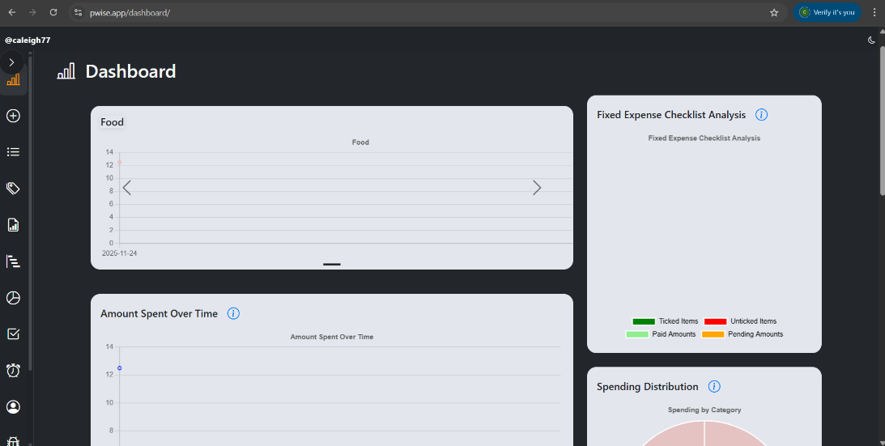
Figure 2.2.1.1 Dashboard
Based on Figure 2.2.1.2, user can add and categorize their daily expenses and group. This is to ensure that every transaction is organized for easier review and analysis. Pennywise allow users to add new category and set the limit of their spending for each category to avoid overspending.
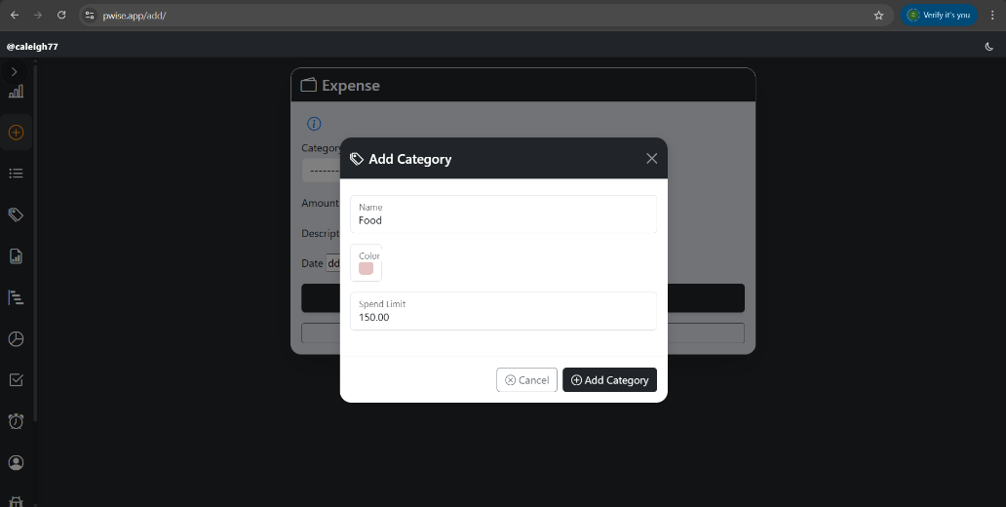
Figure 2.2.1.2 Add Category Popup

Figure 2.2.1.3 shows the add expenses feature in Pennywise system. To add new expenses, user can select the category, enter amount, description of their spending and specify the date of the expense. This process ensures that each expense is accurately recorded that allow clear categorization and easier tracking of financial activities.
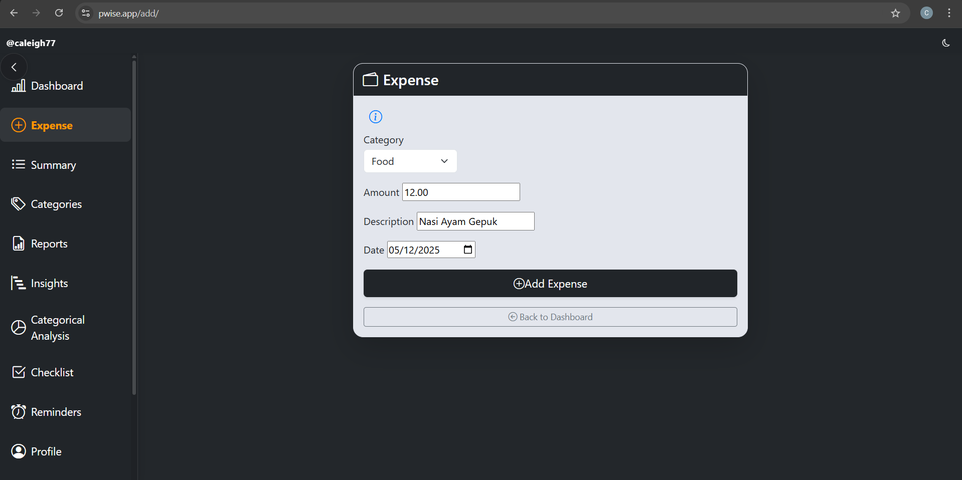
Figure 2.2.1.3 Add Expense

Other than that, Figure 2.2.1.4 illustrates that Pennywise also includes a fixed bill feature where users can set recurring bill amounts and view their payment status. This allows users to track essential monthly commitments such as rent, utilities and loan payment. This feature helps users avoid missed payment and maintain better control over recurring financial obligation.
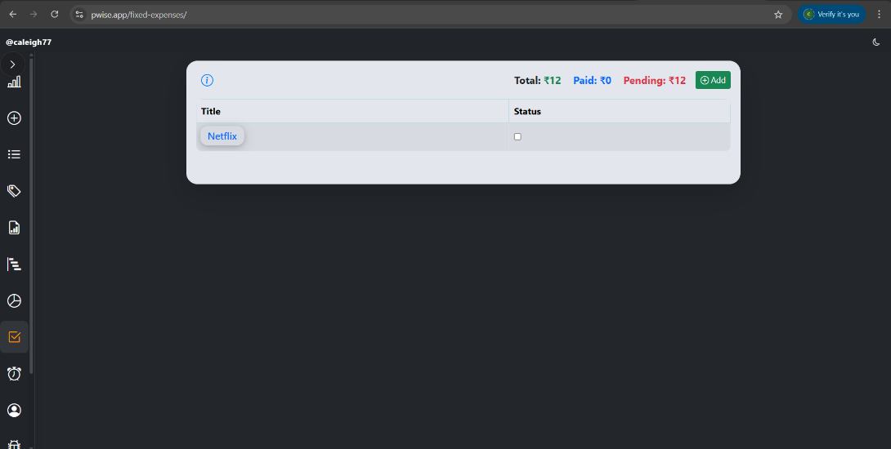
Figure 2.2.1.4 Fixed Bill Feature

To support financial awareness, Pennywise includes customizable financial reminders that can be scheduled by the users at their preferred time and categories as shown in the Figure 2.2.1.5. In addition, this system not only can summarize daily spending, but it can also automatically generate monthly and yearly reports, which can be exported as PDF files for documentation, review or financial planning purpose.
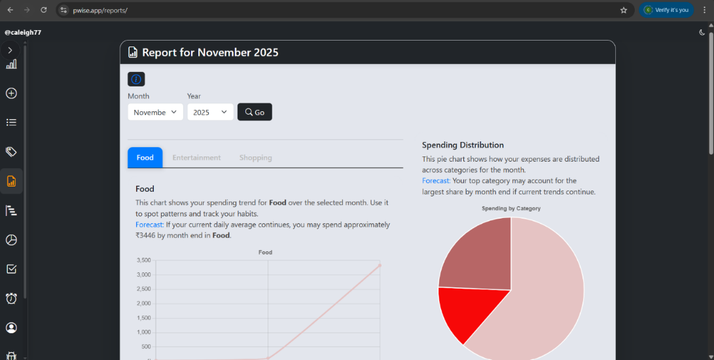
Figure 2.2.1.5 Sample of Report for Monthly Spending
Figure 2.2.1.6 shows the expense summary page in Pennywise system. This page shows users’ transaction list that can be filtered by category, amount and description. Users can also edit and delete their transaction list.
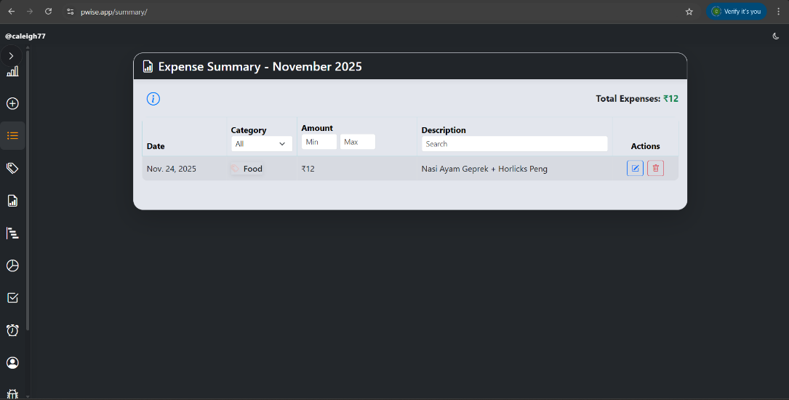
Figure 2.2.1.6 Expense Summary

Based on Figure 2.2.1.7, machine learning model capabilities further enhance the system by identifying spending patterns and predicting future expense. This feature help users make an informed financial decision. Abdulla and Al-Alawi (2024) argue that machine learning empower financial risk management by enhancing risk assessment and decision making.
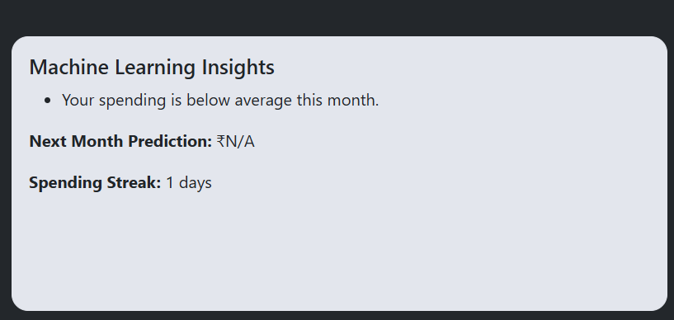
Figure 2.2.1.7 Machine Learning Insights

Limitation & Weakness
Pennywise primarily focuses on expense tracking and budgeting without offering an income management feature. The lacks of income management feature can limit users’ complete view of their overall fiancial status. While Pennywise provides strong tools for monitoring spending and generating reports, the absence of income tracking requires user to rely on external methods or traditional way to record their earnings. Kumar and Jadhav (2025) mentioned that it has been observed that a significant number of people face difficulties in maintaining consistent records of income and expenses when using manual approaches or basic spreadsheet tools. As a result, users may find it more challenging to assess their true financial habit and make a fully informed financial decisions.

2.2.2 System 2: Spendee

System URL
https://www.spendee.com/

System Decsription
Spendee is a modern personal finance management application designed to help user gain a clear visibility and control over their financial activities. The system additionally supports multiple currencies making it suitable for user to handle international transactions. Effective management of budgeting applications across diverse currencies necessitates tools that integrate real-time exchange rates to ensure precise financial monitoring (Frisby, 2025).
Figure 2.2.2.1 displays the transaction list provided in Spendee where users can view and manage all their financial activities in a structured layout. The system provides filter options that allow users to sort transactions making it easier to locate specific records. The simple and organised layout enable users to record financial entries efficiently.
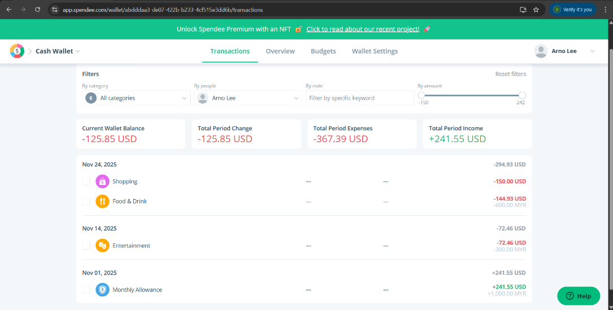
Figure 2.2.2.1 List of Transactions

When it comes to recording new expenses, Spendee allows user to select a category, expenses details and set the transaction as recurring if needed. Figure 2.2.2.2 shows the popup screen of add expense feature in Spendee. This popup making it easier for users to quickly record their expenses and ensure up-to-date tracking.
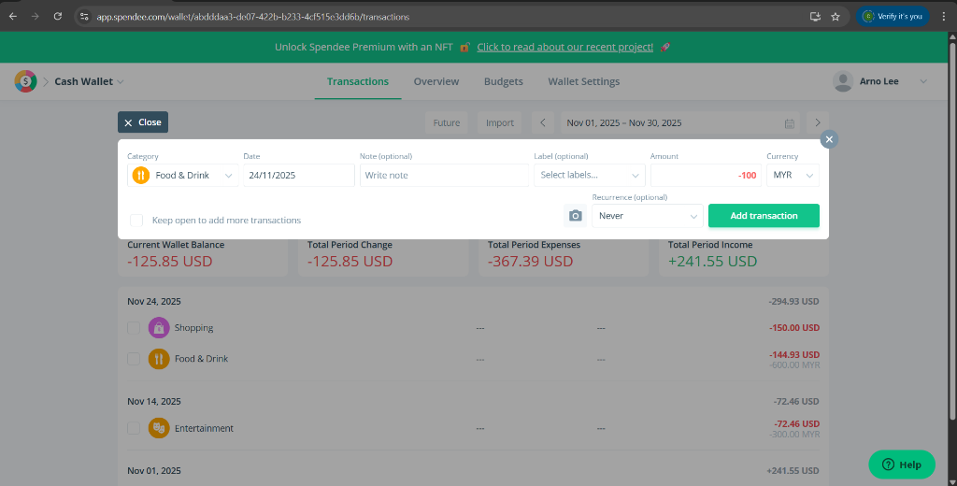
Figure 2.2.2.2 Add Expenses

As shown in the Figure 2.2.2.3, Spendee has a feature called overview that serves as a dashboard which provides users a clear and organized summary of their wallet activity within a selected period. It includes flexible filters for categories, people, notes and transaction amounts. This feature presents key information such as current wallet balance and overall changes during the chosen period, supported by visual charts that display balance trends and transaction movement.
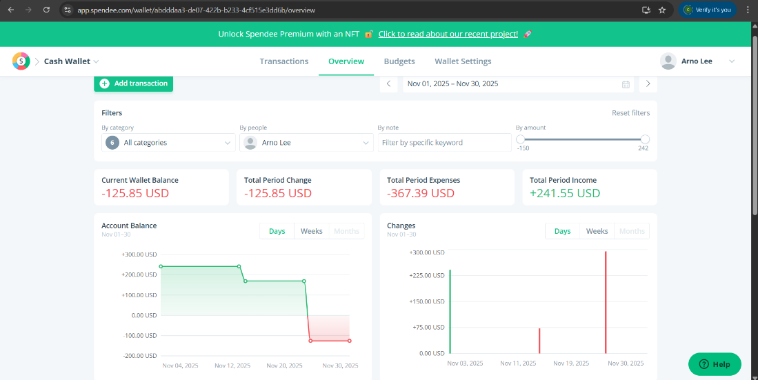
Figure 2.2.2.3 Overview Page
Based on Figure 2.2.2.4, Spendee allows user to track their daily expenses and income with ease, either manually or through automatic synchronization with bank accounts. Expenses and income are imported directly, reducing the need for manual entry and ensuring records remain accurate. Transactions are often categorized automatically, helping users quickly identify spending patterns.
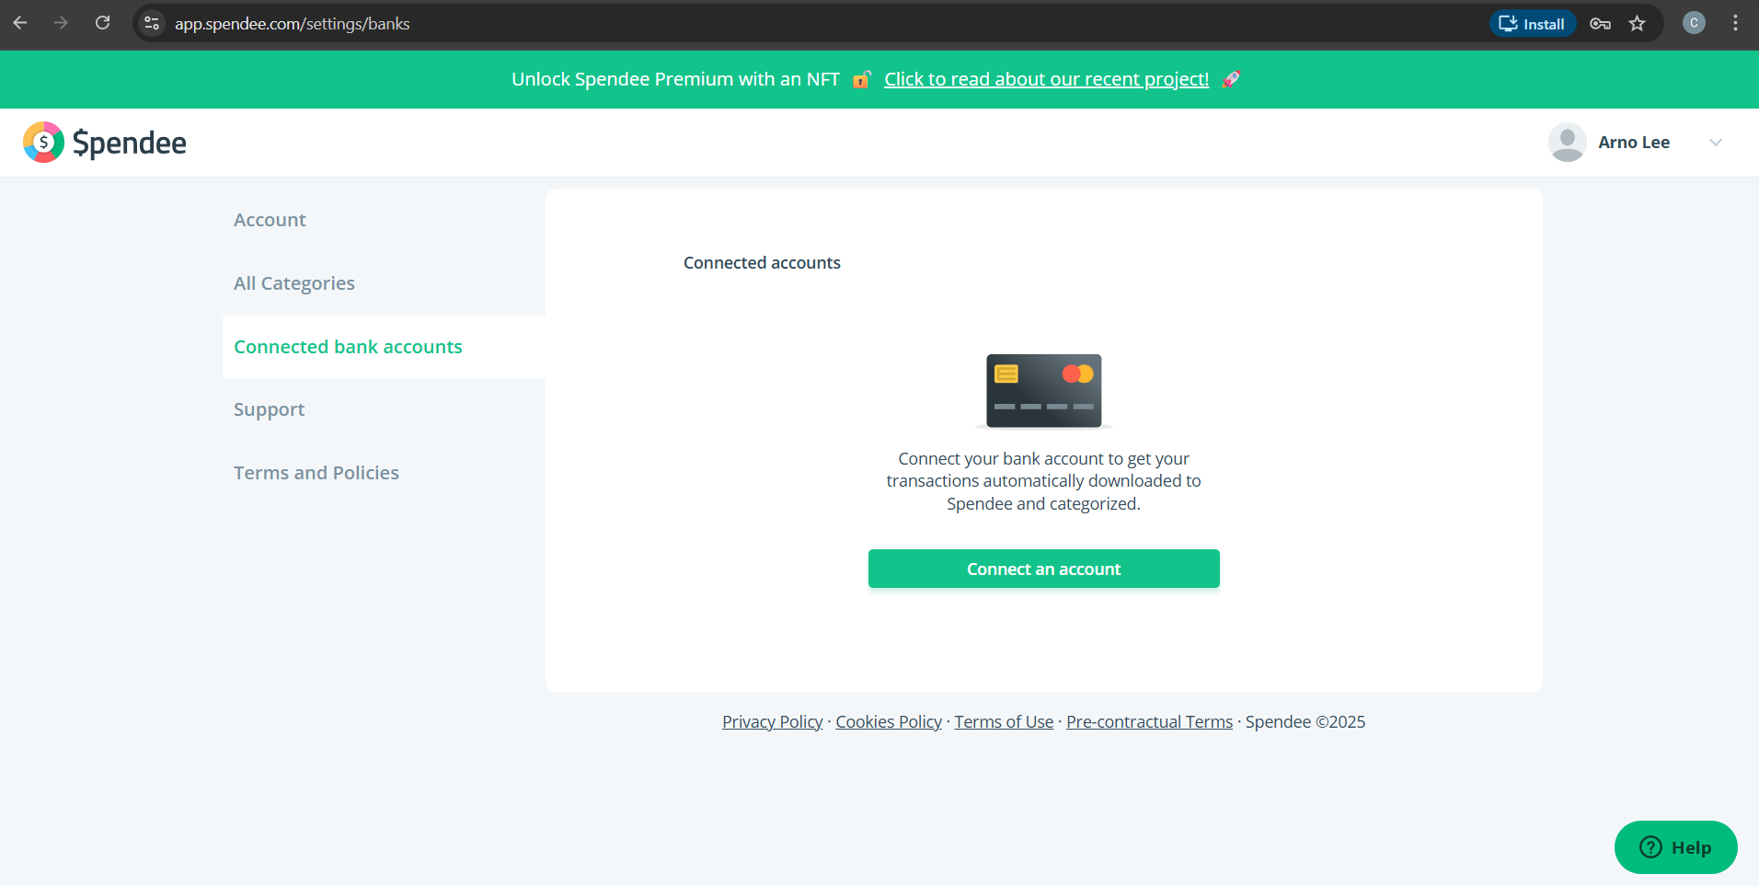
Figure 2.2.2.4 Connected Bank Account Feature

Limitation & Weakness
Spendee offers a standard email-based login system, but this level of security may not be sufficient considering the app is linked to users’ bank account details for real-time transaction syncing. In addition, this synchronization can be limited in coverage and occasionally unreliable, with some banks not supported and technical issues such as duplicate or delayed transactions. Beyond synchronization, Spendee also faces concerns regarding data security, as linking sensitive financial accounts to a third-party platform raises apprehension about privacy and potential breaches. Rajesh et al. (2025) mentioned that some vulnerable systems can reveal sensitive financial details and inadequate authentication enables intruder to gain unauthorized access.

2.2.3 System 3: Goodbudget

System URL
https://goodbudget.com/

System Description
Goodbudget is a personal finance and budgeting app that uses the envelope budgeting method to help users plan and control their spending. Instead of tracking expenses after they happen, the system encourages users to pre-allocate their income into categories so they always know how much they can spend.
Figure 2.2.3.1 displays the Goodbudget dashboard that offers an organized summary of the user’s envelopes and their remaining balances after income allocation and spending. Recent transactions are also listed showing categories, description and amount.
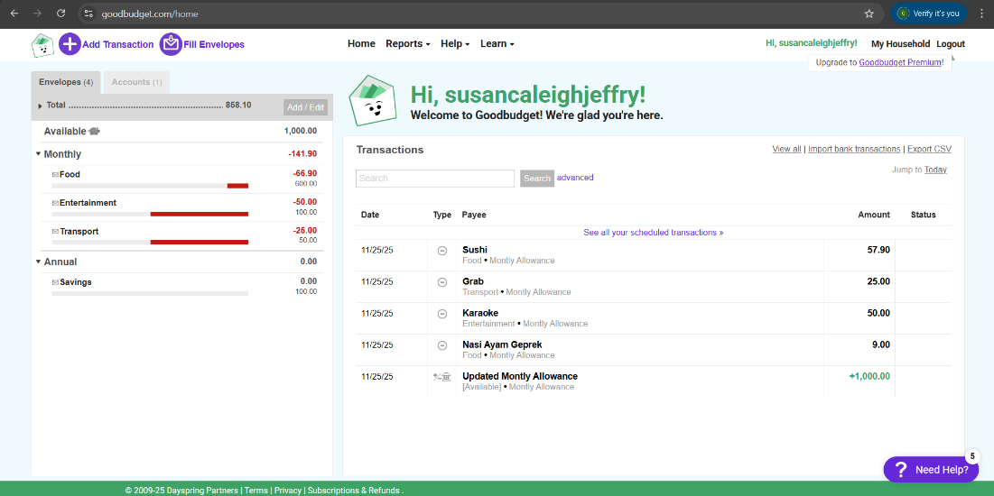
Figure 2.2.3.1 Dashboard that display the List of Transactions

Bai (2023) stated that mental budgeting is a key component of financial well-being, enabling individuals and households to cognitively organize their resources by allocating income into distinct spending categories to maintain effective control over their finances. Hence, Figure 2.2.3.2 shows that Goodbudget allows users to assign their available income to different spending categories, known as envelopes. This feature ensures every portion of the user’s income is intentionally planned and categorized before being spent, supporting a structured budgeting approach.
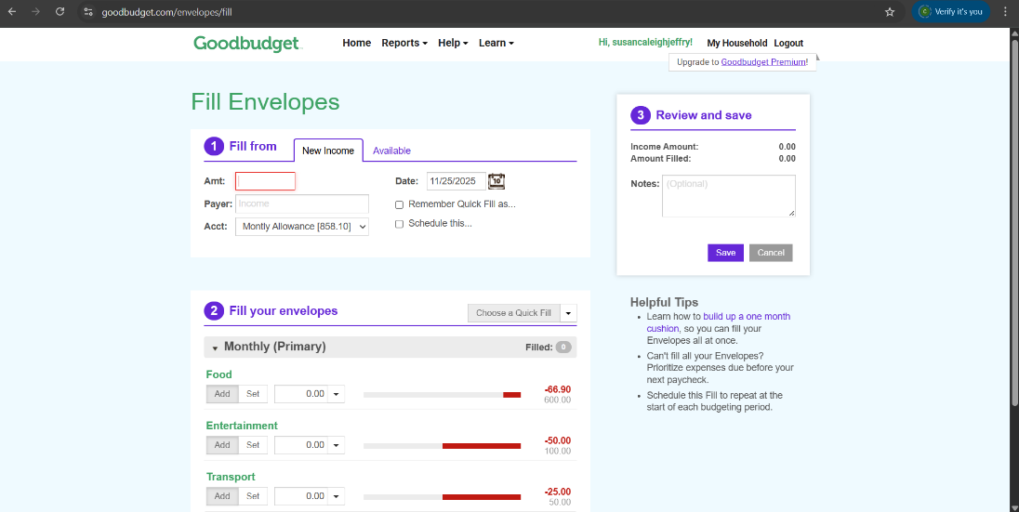
Figure 2.2.3.2 The Fill Envelope page

As shown in the Figure 2.2.3.3, users can enter their transaction details such as date, payee, amount of spending, categories and description of the spending, The system will ensure users’ spending aligned with the allocated budget.
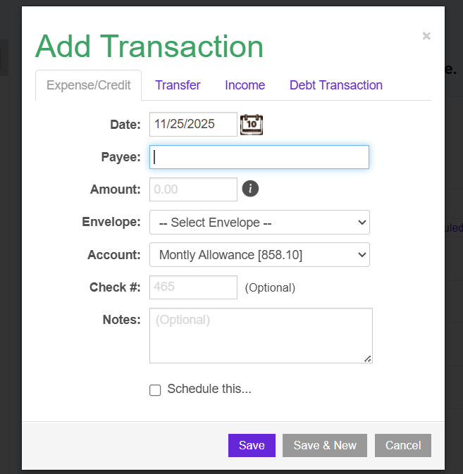
Figure 2.2.3.3 Add Transaction

Goodbudget also offers a visual breakdown of how user’s budget has been used across different spending categories as shown in the Figure 2.2.3.4. This helps users identify their spending patterns and understand which areas take up the largest share of their budget.
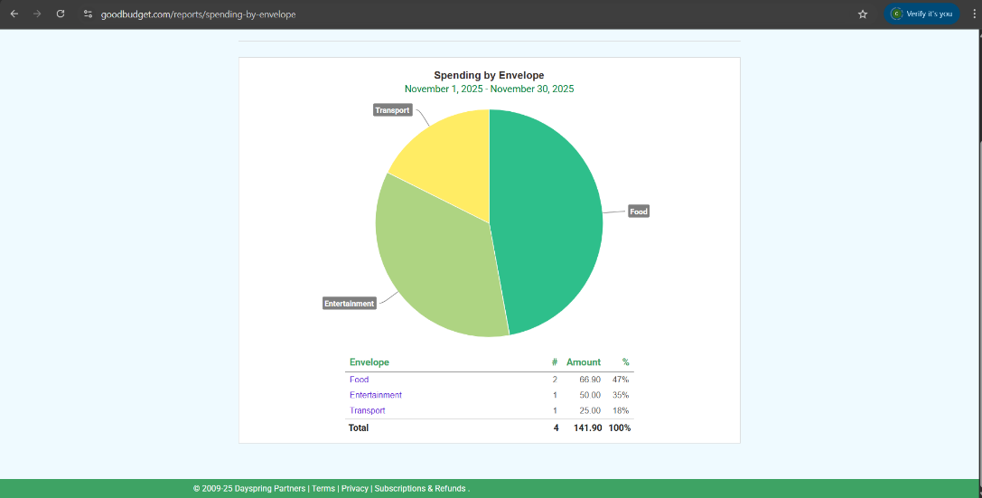
Figure 2.2.3.4 Sample of Pie Chart based on Envelope

Other than that, Figure 2.2.3.5 shows that users can also view the report of their expense, income, budget allocation and the credit expansion.
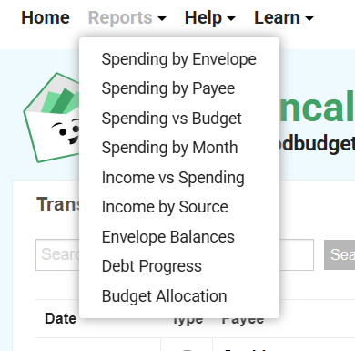
Figure 2.2.3.5 Report Category

Limitation & Weakness
A major limitation of Goodbudget is the absence of advanced analytical functionalities that have increasingly become normative within modern expense tracker. While the system provides a basic spending reports, it does not extend to deeper financial insights such as spending pattern analysis, forecasted budget performance or personalized recommendations based on user behaviour. The progression of these analytical models reflects the practice of financial technology’s readiness to address the inherent complexity of financial system, where traditional statistical methods often prove inadequate (Abdulla & Al-Alawi, 2024). In the absence of these analytical capabilities, users face constraint in managing their financial and detect overspending.

2.3 Comparison Between Existing System and Proposed System
In this section, the core similarities and differences between the three systems are being highlighted and compared with the proposed system. While all aim to enhance financial management efficiency, each system emphasizes distinct features ranging from data interpretability to user engagement. Table 1 illustrates the differences and similarities of existing system and the comparison of the existing system and the proposed system.
Table 1 Comparison Between Similar Existing System and Proposed System
Feature | Existing System |  |  | Proposed System
Feature | Pennywise | Spendee | Goodbudget | Spendette
Add Expenses | User can log daily expenses with category, amount, description and date. | Allow detailed expense entry with category, notes, labels and recurrence. | Users can record expenses under specific envelopes. | Users can input their daily expenses details which are amount, category, date, description, payment method and recurring expenses.
Add Income | Not available in the current Pennywise feature set. | Income entry supported with categories and currency options. | Income added into income envelopes to allocate budget. | Allows detailed income logging including source, date, amount, description and categorization.
Expense Tracking | Track all expenses and displays them clearly in history | Track transaction with filtering and breakdown summaries. | Tracks spending based on envelope allocations. | Offers a full breakdown of the transaction details with filters feature.
Add Expenses Category | User can create and customize categories. | Categories available but limited customization in free version. | Categories are predefined under envelopes. | Fully customizable categories designed to match user lifestyles and spending habits.
Group Expense Feature | This functionality is not available in the system. | This functionality is not available in the system. | This functionality is not available in the system. | The system offers group expense feature.
Dashboard | Interactive dashboard with charts and summaries. | Overview dashboard with balance, income and expense visuals. | Simple envelope-based dashboard showing remaining budget. | Personalized dashboard with real-time summaries, machine learning insights and spending habits
Report Generation | Monthly/Yearly PDF reports are downloadable. | Provides spending insights and downloadable reports. | Provides basic reports based on envelopes and spending history. | Produces a report with category comparisons and spending history.
Reminder & Notification | Finance reminders via email and system notification. | Notification for planning and payment alerts for premium users only. | No built-in reminder or notification systems. | The reminder will be sent directly to the users’ email for better visibility and timely action.
Login & Security | OTP-secured login and registration. | Standard email and password login. | Basic login system without advanced security layers. | Uses username and password to log in with integrated CAPTCHA authentication.
Fixed Bills Management | Users can set recurring bills. | Recurring transactions available. | No dedicated recurring payment feature. | Fully supports recurring bills and monthly summary of fixed commitment.
Machine Learning Model | Auto-categorisation and spending prediction. | Auto categorisation available in premium version only. | No machine learning integrations. | Uses machine learning to detect unusual spending, generate personalized insight and predict upcoming based on spending patterns.
Security Feature | OTP, encrypted user data and secure authentication. | Standard secured login and extra protection available in premium version. | Basic security with no advanced protective features. | Secured authentication and encrypted user data.

The table shows the comparison between the proposed system and the similar existing systems that highlights significant differences in functionality, flexibility and overall user support. The proposed system is Spendette, a financial management system with machine learning support.
Spendette provides the most comprehensive feature set. The proposed system supports detailed expense tracking, income recording, full category customization, interactive dashboard and financial reports. Spendette also includes email-based reminders, ensuring users stay updated on bill due dates, spending limits and budgeting alerts. In addition, Spendette has integrated machine learning component which offers personalized budgeting recommendations and spending insights based on user behaviour. David et al. (2024) mentioned that machine learning can handle large amounts of data and uncover patterns that traditional statistical methods may overlook. Hence, Spendette offers an advanced features to help users in their individual financial management.

2.4 Technologies Review
The development of Spendette relies on combination of web technologies, backend frameworks, database and machine learning algorithms designed to support an efficient financial management system. On the frontend side, Spendette is built using HTML, CSS and JavaScript. These languages are widely used as the fundamental technologies for creating responsive and user-friendly web interfaces. HTML defines the structure of a webpage, CSS controls its visual presentation, and JavaScript adds interactivity and dynamic behaviour allowing the web application to be well-organized and user-responsive web applications (Challapalli et al., 2021). These programming languages are commonly used in expense tracking systems due to their lightweight nature and cross device compatibility.
On the server side, Spendette uses PHP as the backend language and MySQL (SQL) as the database management system. PHP is a well-established scripting language known for its stability and seamless integration with MySQL. This making it suitable for authentication, data prosecssing and CRUD operations in financial management systems. SQL databases are also ideal for handling structured financial records due to their high consistency and relational data design.
To advance the systems, Spendette integrates with machine learning model, specifically Random Forests. According to Siddique and Wahid (2025), Random Forest is an ensemble learning algorithm that effectively addresses classification and prediction tasks by managing complex non-linear relationship and multiple predictors while reducing overfitting, making it particularly valuable in retail contexts with numerous influential variables. In this project, the machine learning model will be trained within the system to generate personalized budget recommendations for users and to detect potential overspending. Real-time spending forecasts advance financial planning by enabling users to allocate resources effectively, make an analytically decisions and manage expenditures proactively to achieve their financial objectives and sustain financial well-being (Lingayat et al., 2024). These capabilities illustrate how the integration of advanced machine learning can actively support user financial decision.

2.5 Chapter Summary
This chapter presents a comparison of three existing systems related to the proposed solution, with the aim of identifying their strengths, weaknesses, and functional gaps. By analysing these systems in detail, the chapter provides insights that inform and guide the enhancement of features in the proposed system, ensuring it offers a more comprehensive and effective user experience. This chapter also outlines the review of technologies used in the development of proposed system.

References
Abdulla, Y. Y., & Al-Alawi, A. I. (2024). Advances in Machine Learning for Financial Risk Management: A Systematic Literature Review. Advances in Machine Learning for Financial Risk Management: A Systematic Literature Review, 531–535. https://doi.org/10.1109/icetsis61505.2024.10459536
Challapalli, S. S. N., Kaushik, P., Suman, S., Shivahare, B. D., Bibhu, V., & Gupta, A. D. (2021). Web Development and performance comparison of Web Development Technologies in Node.js and Python. 2021 International Conference on Technological Advancements and Innovations (ICTAI), 303–307. https://doi.org/10.1109/ictai53825.2021.9673464
David, L. K., Wang, J., Cisse, I. I., & Angel, V. (2024). Machine learning algorithms for financial risk prediction: A performance comparison. International Journal of Accounting Research, 9(2), 49-55. https://j.arabianjbmr.com/index.php/ijar/article/view/1226/1130
Frisby, D. (2025). How to manage budgeting apps when you have accounts in different currencies. MoneyBib. https://moneybib.com/budgeting/how-manage-budgeting- apps-when-you-have-accounts-in-different-currencies
Gehlot, S., Gupta, P., Chavan, K., Bhavish, Pournim (2024). An expense tracker. International Journal for Research in Applied Science and Engineering Technology, 12(5), 4783– 4788. https://doi.org/10.22214/ijraset.2024.62268
Kumar, H. & Jadhav, P. D., (2025). Expense Tracker using .NET. Peer-reviewed Journal. https://doi.org/10.17148/IJARCCE.2025.14812
Kurniawan, D. E., Iqbal, M., Friadi, J., Hidayat, F., & Permatasari, R. D. (2021). Login Security Using One Time Password (OTP) Application with Encryption Algorithm Performance. Journal of Physics Conference Series, 1783(1), 012041. https://doi.org/10.1088/1742-6596/1783/1/012041
Lingayat, L., Yadav, N., Rathod, P., Durutkar, P., & Ghode, S. (2024). Design and implement of real time expense tracker using ML. SSRN Electronic Journal. https://doi.org/10.2139/ssrn.4754463
Rajesh, P., Sai, M. D., Narasimha, Y. J. R., Prasad, K. M. S., Naveen, A., Kumar, B. J. S. S., TejVarma, G. (2025). Expense Manager: a comprehensive Web-Based solution for financial tracking. International Journal for Research in Applied Science and Engineering Technology, 13(4), 2031–2039. https://doi.org/10.22214/ijraset.2025.68687
Sabirin, S., Benius, B., Neneng, S., Nurwati, S., & Hendrayati, S. L. (2023). Importance of early financial literacy management skills. International Journal of Business Economics & Management, 6(2), 100–106. https://doi.org/10.21744/ijbem.v6n2.2120
Trevor, R. T., Rakgwata, P. A., & Zwivhuya, D. M. (2025). Shared living, shared burdens: A case of the university of Venda exploring the impact of cohabitation on students’ financial stability. International Journal of Research in Business and Social Science (2147-4478), 14(6), 288–296. https://doi.org/10.20525/ijrbs.v14i6.4058

